Low Level Design (Registration module)

Project Code | Team1
Project Name | CapStore (E-commerce - application)

Prepared/Modified by | Role | Date of Preparation
Vinitha Narvaneni | Analyst | 12/12/2018
Reviewed by | Role | Date of Review
Approved by | Role | Date of Approval
Circulation List |  | Version Number of the template:1.0
Version Number

Table of Contents

1. Description Of The Unit 3
2. References 4
3. Dependencies / Assumptions 5
4. Class Diagrams 6
5. Sequence Diagrams 7
6. Design Components 8
6.1 List Of UI Components 8
6.2 List Of Design Classes 8
7. Re-Usable Routines/Components 9
8. Messages 10
9. Configuration Files 11
10. Crud Matrix Table 12
11. Data Mapping Matrix 13
12. Action Flow Matrix 14
13. Stored Procedures 15
14. Program Specification / Pseudo Code 16
REVISION HISTORY OF THE WORK PRODUCT 17

Description Of The Unit

The Image Upload module allows the Admin of the application to upload images into database and therefore the images of the products are stored into database.
The Uploaded images can be used by other modules i.e., for displaying products, coupon codes, etc.,

References

Reference | Description
Repository reference | https://IGTEBLRSVNTNG.igatecorp.com/svn/oct3_Team1
Class Diagram | /Project Documents/Design Documents/HLD/Class Diagrams
URS | /Project Documents/Requirements/Case Study/Ecommerce-grp1 and grp3.doc
UTP | /Project Documents/Test Plan/UTP/Test Cases/Registration Module
DB Design | /Project Documents/Design Documents/HLD/DB Design/E-Commerce_GROUP_DBDESIGN.xls

Dependencies / Assumptions

Assumptions:
The Image should be in jpg or png format only.
The size of image should be less than 2 MB.
The Name of the image should be relevant.

Class Diagrams

Class Diagram

Sequence Diagrams

Sequence Diagram
N/A

Design Components

List Of UI Components

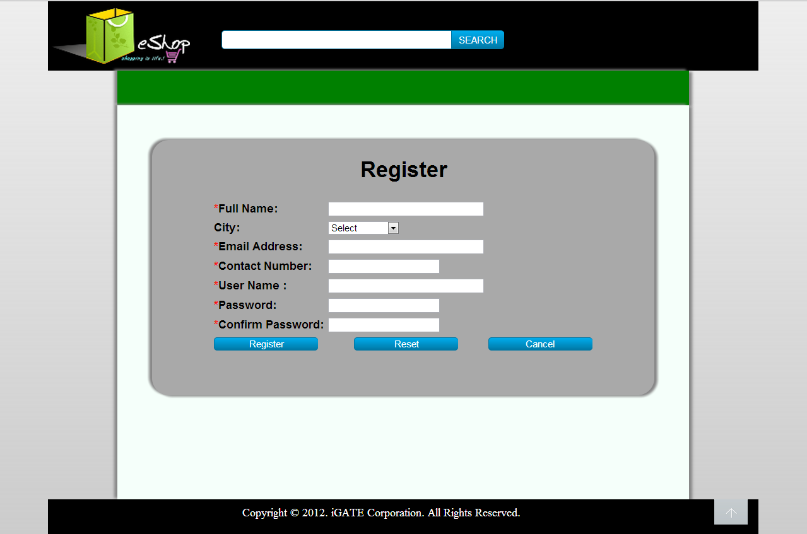

List Of Design Classes

Sr. No. | LLD Name | Class Name | Method Name | Method Description
1 | Register Module | Customer | Appropriate getters and setters methods | Getters retrieve the property values and setters set the property values
2 | Register Module | EshopController | prepareRegister(Model model):String  checkRegister(@ModelAttribute  (“customer”)@Valid Customer customer, ,BindingResult result ,Model model):String | Sets the model attribute.  Calls registerUser() of EshopBOImpl class which in turn calls registerUser() of EshopDAOImpl and the details of  visitor are entered into the database.
3 | Register  Module | EshopBOImpl | registerUser(Customer customer):int | Calls registerUser() of EshopDAOImpl class and returns the result to EshopController.
4 | Register  Module | EshopDAOImpl | registerUser(Customer customer):int | Adds the details to the database and returns the result to EshopBOImpl.

Re-Usable Routines/Components

Re-Usable Routines/Components

- CSS files
- Javascript files
- DataAccessException class
- Database properties files
- Logger properties files

Messages

#. | Type | Message Text
M1. | Error | Select Image to Upload
M2 | Error | Image size should be less than 2Mb.
M3 | Error | Select only JPG or PNG image
M4 | Message | Image Uploaded successfully

Configuration Files

File Name | Path | Description
oracle.properties | /Development/Source | To configure database connection.
Web.xml | /Development/Source | To configure the bean properties.
Dispatcher-servlet.xml | /Development/Source | To configure the request mapping and view resolver.
Eshop_logger.properties | /Development/Source | To configure the logger.
Eshop_error.properties | /Development/Source | To configure error messages.

Crud Matrix Table

# | Table Name | Create | Read | Update | Delete
1 | User | Y | N | N | N
2 | Customer | Y | N | N | N

Data Mapping Matrix

Sr. No. | Screen Label | Field Source | Field Type | Data Type | Max Length | Data Flow | Mandatory
1 | Full Name | N/A | Label | N/A | N/A | UI | N/A
2 | txtCustomerName | Customer.  customerName | TextBox | Varchar2 | 30 | UI→D | Yes
3 | User Name | NA | Label | N/A | N/A | UI | N/A
4 | txtCustomerId | Customer.  customerId | TextBox | Varchar2 | 10 | UI→D | Yes
5 | City | N/A | Label | N/A | N/A | UI | N/A
6 | optCustomerCity | Customer.  customerCity | ComboBox | Varchar2 | 30 | UI→D | Yes
7 | Email Address | N/A | Label | N/A | N/A | UI | N/A
8 | txtCustomerEmailId | Customer.  customerEmailId | TextBox | Varchar2 | 30 | UI→D | Yes
9 | Password | N/A | Label | N/A | N/A | UI | N/A
10 | txtPassword | User.password | TextBox | Varchar2 | 20 | UI→D | Yes
11 | Confirm Password | N/A | Label | N/A | N/A | UI | N/A
12 | txtConfirmPassword | User.password | TextBox | Varchar2 | 20 | UI | Yes
13 | Contact Number | N/A | Label | N/A | N/A | UI | N/A
14 | txtCustomerMobile  Number | Customer.  customerMobile  Number | TextBox | Varchar2 | 10 | UI→D | Yes
Sr. No. | Screen Label | Field Source | Field Type | Data Type | Max Length | Data Flow | Mandatory
15 | Register | NA | Button | NA | NA | UI | NA
16 | Reset | NA | Button | NA | NA | UI | NA
17 | Cancel | NA | Button | NA | NA | UI | NA

Legend

UI (User Interface Only)
UI → D (User Interface to Database)
D → UI (Database to User Interface)

Action Flow Matrix

Sr. No. | Action | Description | Process
1 | On click of Register Button | Valid User details are stored in to the database. | Customer details are validated if valid details are added to database the customer is navigated to Home Page, else he/she is navigated to the error page.

Stored Procedures

# | Stored Procedure Name  (with Description) | Input/Out Parameters | Type | Size
1. | NA | NA | NA | NA

Program Specification / Pseudo Code

14. 1 <ACTION: ONPAGE_LOAD>

Pseudo Code:

- Client Side Scripting
None
- Server Side Scripting

BEGIN
Calls prepareRegister(Model model) in EshopController class.
Navigates to Register Page.
END

14. 2<ACTION: REGISTER_CLICK>

Pseudo Code

- Client Side Scripting:

IF Full Name Filed is Empty
Print Error Message M1
IF Full Name is Invalid
Print Error Message M2
IF User Name Filed is Empty
Print Error Message M3
IF User Name is Invalid
Print Error Message M4
IF User Name >10 characters
Print Error Message M5
IF Email Id Filed is Empty
Print Error Message M6
IF Email Id is Invalid
Print Error Message M7
IF Password Filed is Empty
Print Error Message M8
IF Password length is >16
Print Error Message M9
IF Confirm Password Filed is Empty
Print Error Message M10
IF Confirm Password not same as Password
Print Error Message M11
IF Contact Number Filed is Empty
Print Error Message M12
IF Contact Number is Invalid
Print Error Message M13
IF Contact Number length is >16
Print Error Message M14

- Server Side Scripting:
BEGIN
Call prepareRegister (Model model) in EshopController class in Presentation Layer
BEGIN
Call registerUser(Customer customer) in EshopBOImpl class in Service Layer
BEGIN
Call registerUser(Customer customer) in EshopDAOImpl class in Data Access Layer
BEGIN
Create query to insert data in to User and Customer table
Return integer indicating if inserted or not
END
The result of the query is stored in an integer variable.
END
Return integer value to Service Layer
END
Return integer value to EshopController
END
IF true navigate to Home Page
REVISION HISTORY OF THE WORK PRODUCT

# | Date | Version # | Section Changed | Details of changes made | Approved By
1 | 16/12/2013 | 1.0 | LLD prepared | N/A | Uma M Ponniamman
2 | 17/12/2013 | 1.1 | Reusable components,  Pseudo Code,  Data Mapping Matrix. | Reusable components added.  More specific control flow specific.  More rows were added specifying the buttons of the form. | Uma M Ponniamman
3 | 18/12/2013 | 1.2 | Reusable components,  References,  Data Mapping Matrix. | Reusable Components added.  File name with relative path is added in the references section.  The name of text boxes(screen label is changed). | Uma M Ponniamman
4 | 20/12/2013 | 1.3 | Messages | Changes made in Error Messages. | Uma M Ponniamman
5 | 24/12/2013 | 1.4 | Configuration files,UI Components | Paths of the configuration files is updated and UI components(Screen Shots) added. | Uma M Ponniamman

